27.13: a) 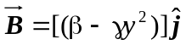and we can calculate the flux through each surface. Note that there is no flux through any surfaces parallel to the y-axis. Thus, the total flux through the closed surface is:
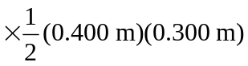
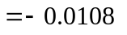Wb.

b) The student’s claim is implausible since it would require the existence of a magnetic monopole to result in a net non-zero flux through the closed surface.

